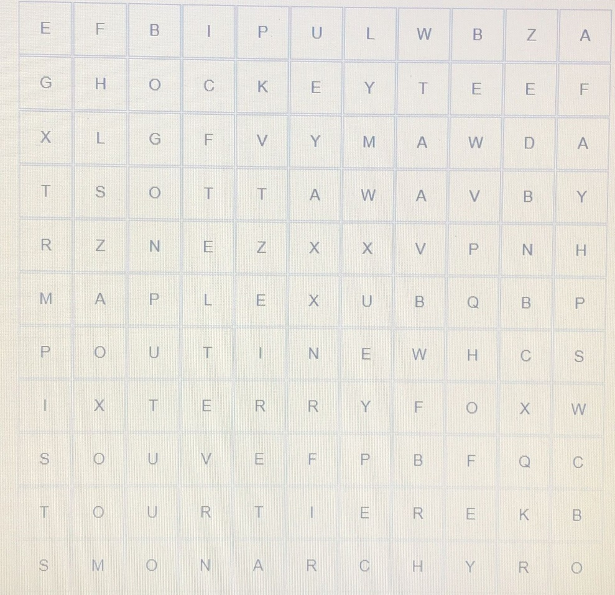 WORDS:

TERRYFOX

POUTINE

MONARCHY

TOURTIERE

MAPLE

HOCKEY

OTTAWA

MAWDA